TR80+
G30 METAL PROFILED SHEET DECKING

110 PROPRIETARY SPECIFIED METAL PROFILED SHEET DECKING (FOR FLOORS)

Manufacturer: Structural Metal Decks Ltd
The Outlook, Ling Road, Tower Park, Poole, Dorset, UK BH12 4PY
Website: www.smdltd.co.uk Telephone: +44 (0)1202 718898

Profile reference: TR80+ trapezoidal composite floor decking (600mm cover width)

Material: Hot dip galvanized structural quality steel strip to BS EN 10143 & BS EN 10346 with a minimum coating mass of 275g/m² (Standard) / Hot dip galvanized structural quality steel strip to BS EN 10143 & BS EN 10346 with a minimum coating mass of 310g/m² (HD)*

Grade: S350 or S450* (minimum yield strength 350N/mm² of 450N/mm²)*

Nominal thickness: 0.9mm / 1.0 mm / 1.2mm*, as required to suit load / span criteria.

Soffit finish: Plain galvanized - any additional paint coating required to be site applied by others

Attachment: As clause 280

Floor decking: Deck span direction and shear stud requirements as specified on engineer’s drawings

Accessories: Shear studs (refer clause 140), end caps and edge trim/flashings to form slab edges to perimeter and service voids (1.0 to 2.0mm)

Design: The decking contractor to provide detailed layout drawings indicating the floor decking and all necessary accessories. Refer to decking manufacturer load / span tables and / or software for span limits. For specific design criteria outside the scope of manufacturer’s literature contact SMD Technical Department.

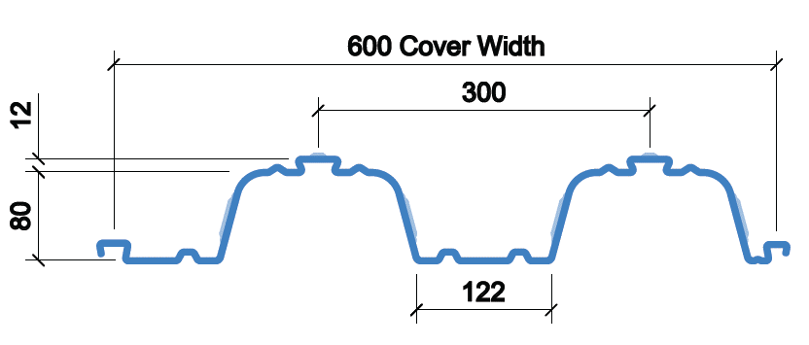
*delete as applicable

140 SHEAR STUDS

Manufacturer: Nelson Stud Welding UK or similar approved
Size: 19mm diameter x 120mm length after weld
Material Properties: Type SD with minimum yield strength of 350N/mm² and ultimate tensile strength of 450N/mm² in accordance with BS EN ISO 13918

180 DESIGN REQUIREMENTS FOR DECKING

Material: Steel, Grade S350 or S450* GD +Z275 to BS EN 10326 (Standard) /
Steel, Grade S350 or S450* GD +ZM310 to BS EN 10326 (HD) *

Depth of Profile: 80mm trapezoidal profile

Configuration: All decking sheets to be double span where possible. Refer manufacturer’s load / span information for single span limits where required.

Bearing: 50mm on steel and 70mm on other materials, unless otherwise specified

Maximum Sheet Length: 10.0m maximum recommended due to manual handling restrictions

Soffit Finish: Plain galvanized

Maximum deflection: In accordance with BS 5950-4 or BS EN 1994-1-1.

183 DELIVERY AND STORAGE OF DECKING

Handling: Decking to be carefully offloaded and handled to avoid damage that may affect the structural performance of the sheets.

Storage: Where sheets are required for immediate use, packs should be loaded directly onto supporting frame ensuring adequate bearing is achieved. Where decking packs are to be stored on site for future use, they should be supported on timber battens not more than 2.0m apart and offering at least 100mm clearance above the ground.

Water run-off: When stored on site, packs should be laid to a slight fall (1 in 60) to prevent pooling of rain water.

