G30 METAL PROFILED SHEET DECKING

200 FIXING DECKING

210 STRUCTURE

Check that the structure is in a suitable state to receive the decking before commencing fixing.

220 PAINTING STRUCTURE

Sequence: Prior to fixing decking paint surfaces of supporting structure that will be subsequently inaccessible

Top Flanges: Where steel beams are to receive thru’ deck welded shear studs, the entire top flanges are to be free from any type of paint (including ‘weldable’ paints), grease, loose rust or other coating to ensure effective welding and adequate weld strength is achieved.
Masking of a small section of the top flange is not acceptable, if a return of paint from the toe of the beam top flange is required, this should be no greater than 10mm.

230 PREVENTION OF ELECTROLYTIC ACTION - ISOLATING TAPE

Not required for typical applications. Where deemed necessary, apply to interfaces between dissimilar metals. Of a type recommended for the purpose by decking manufacturer.

240 FIRE RESISTING PROFILE FILLERS

Supplier: Fire Protection specialist and/or fit-out contractor

Type/Shape: To match profile geometry, contact decking manufacturer for suppliers’ details

Length: To full width of support, unless noted otherwise

Location: Refer architects details/requirements

Fixing: Bonded into position using adhesive as recommended by profile filler manufacturer

260 FIXING DECKING GENERALLY

Installation: In accordance with decking manufacturers literature and BCSA Code of Practice for Metal Decking and Stud Welding – Publication No. 37/04

Fixing: Low velocity powder, gas actuated or screw fixings to suit the support material – As clause 280.

Cutting of decking:
To a true and even line ensuring no distortion/damage to profile.

Butt joints over supporting steelwork:
Where possible decking is to butt join and ends with ribs lining through.

Gaps at butt joints or around columns:
Where gaps are in the region of 3-5mm no additional sealing is required. Gaps greater than 5mm are to be sealed using end caps, flashing offcuts, tape or expanding foam to minimise grout loss.

Trough closure at ends of decking ribs:
End caps (light gauge angle flashing) provided and installed where necessary.

260 FIXING DECKING GENERALLY CONTINUED…..

Top surface of supporting beam flanges:
As clause 220 and ensure beam flanges are clean prior to laying out decking sheets.

270 SHEAR STUD WELDING GENERALLY

Before starting work:
Pre-production tests to be carried out to demonstrate suitability of materials, equipment and welding system proposed – in accordance with BCSA Code of Practice for Metal Decking and Stud Welding – Publication No. 37/04.

Testing:
Pre-production and production testing of thru’ deck welded shear studs to be carried out in accordance with BCSA Code of Practice for Metal Decking and Stud Welding – Publication No. 37/04.

Failed test studs:
Adjust set up and repeat test in accordance with BCSA Code of Practice for Metal Decking and Stud Welding – Publication No. 37/04.
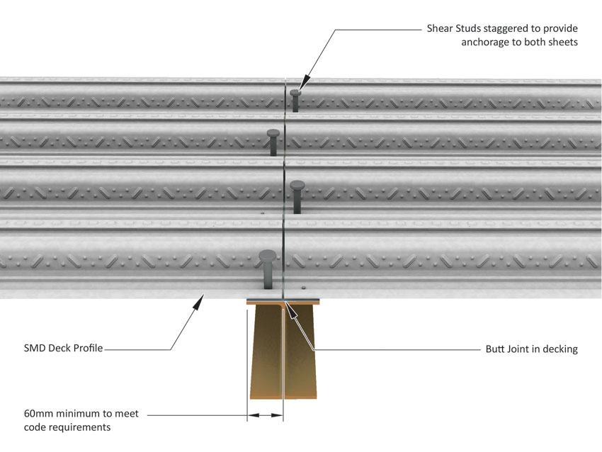

Typical Stud Detail at Butt Joint (TR+ Profiles)

280 ATTACHMENT OF DECKING

Primary Deck Fasteners:
Low velocity powder or gas actuated fixings, as follows:

i) Hilti X-U 15, Hilti X-P14 G3MX, Spit SDK9 or similar approved where steel beams are to receive thru’ deck welded studs

ii) Hilti X-ENP 19, Spit SBR14 or similar approved where steel beams are un-studded

iii) Drill, plug and screw fixings or Hilti X-SW, Spit CR9P or similar approved to block work, masonry or concrete.

280 ATTACHMENT OF DECKING CONTINUED…...

Number of fasteners at supports:
Fixings at 300mm centres at sheet ends and 600mm centres at intermediate supports (or closest multiples to suit profile trough centres).

Side Lap Stitching:
1.0m centres starting from mid-span using self-tapping screws.

280 ATTACHMENT OF DECKING CONTINUED…..

Fastener Locations:
In troughs of profile, positioned to avoid clash with thru’ deck welded shear stud position.

290 COLD FORMED METAL ACCESSORIES

Types: Edge trim/closure flashings as detailed on decking layout drawings

Material: Hot dip galvanized steel strip to BS EN 10143 & BS EN 10346 with a minimum coating mass of 275g/m²

Thickness: 1.0, 1.2, 1.6 or 2.0mm to suit slab depth and overhang dimension

Finish/Colour: Plain galvanized

Fixings: Fixed to structure using similar fixings as used for installing the decking at 750mm centres

Attachment to decking:
Flashings (closure pieces) and edge trim restraint straps fixed to decking sheets using self-tapping screws

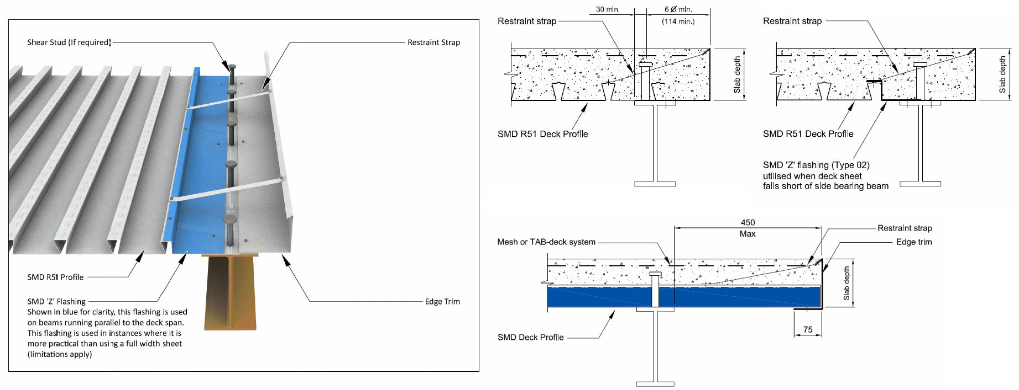
Typical Edge Trim and flashing details (R51 Profile)

