G30 METAL PROFILED SHEET DECKING

300 FIXINGS TO THE UNDERSIDE OF COMPOSITE FLOOR/SLAB

Specification: Proprietary wedge nut fixings are available to suit differing profile geometries with a safe working load of 1kN per fixing.

Manufacturer: Lindapter International
Lindsay House, Brackenbeck Road, Bradford, West Yorkshire, UK BD7 2NF
Website: www.lindapter.com Telephone: +44 (0)1274 521 444

Installation: To avoid possible localised overloading of the slab, fixings should not be locally grouped. As a guide nominal 600mm grid spacing is recommended as a minimum. Refer to manufacturer’s guidance for installation.

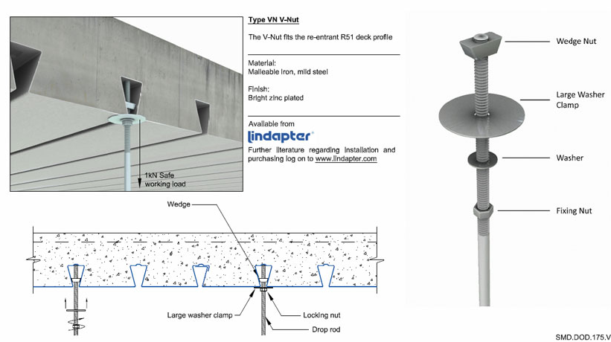
‘V’ Nut wedge to suit R51 re-entrant profile

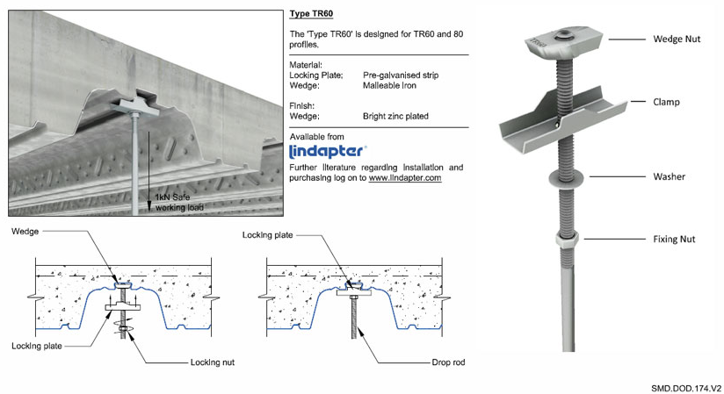
TR60 wedge to suit TR+ profiles (suitable for both TR60+ and TR80+)

